CS 2031: Telecommunications II

Assignment 1.1 Report

Ryan
Barron
Student number: 16329561

The two programs, ReceiverProcess and SenderProcess are used to send and receive a packet of data to the same computer. The protocol used is UDP and the IP address is the same for the source and destination, it uses a link-local address. The port number for the source is 54600 and the destination port number is fixed to 12345. The packet captured has the header of the datagram and the payload, “Hello World”.
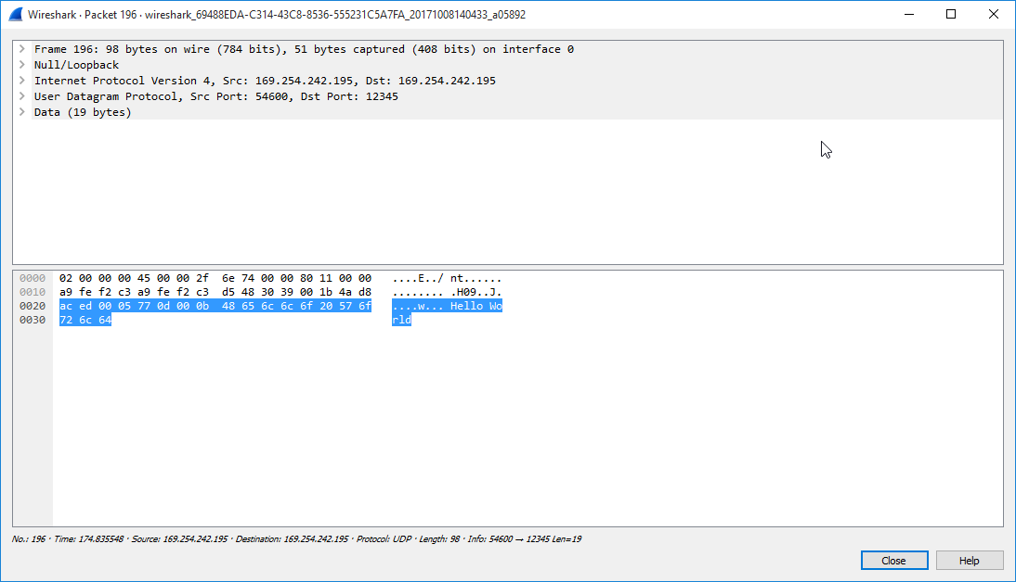
The program works by first starting ReceiverProcess so that the computer can receive the packet and then SenderProcess is run. The packet is then send, ReceiverProcess takes it, prints out the message and terminate. Using Wireshark I was able to see the trace of the transmission and took a screenshot of it.

